The Molecular Connection

Arizona Science Standards:
- S4-C4-PO3, 5, 6

Ag Standards:
- 17.4 –Portray the scientific principles and processes involved with biological evolution

Objectives:
- Recognize how comparisons of similarities and differences in molecular structure can suggest evolutionary relationships
- Understand the importance of multiple lines of evidence in identifying evolutionary relationships
- Understand how animal body plans are dictated by homeobox, master control genes
- Recognize the evolutionary relationship between organisms based on similar genes
Background:
During 2nd quarter, we discussed DNA and how genes are recipes to create living things. For the past few days we have been looking at physical traits, phenotypes, of organisms and how they show change over time. Today, we will be examining molecular evidence, or genotypes.
Molecular evidence contributes to the picture of how change over time has occured. Molecular biologists are able to determine and compare the DNA base sequences and the amino acid sequences of the same proteins from different animals. Cytochrome-c is an important protein found in virtually all organisms, so it is an easy protein to compare. Remember that Cytochrome-c is only one of many proteins found in the body, so today you are looking at a snapshot of the body.
When comparing Cytochrome-c the less closely related species are, the more differences there are in their DNA base or amino acid sequences, as there would be more time for mutations to accumulate. Conversely, the more closely related species are, the fewer differences there are.
Molecular and anatomical studies have been conducted to determine the relationships between living organisms. The phylogeny determined by each line of evidence is then compared. Just as Darwin presented different lines of evidence to support his theory of evolution, scientists today rely on finding new and multiple lines of evidence—fossil, anatomical, molecular, and biogeographical—to determine the evolutionary relationships of different species
Today you will compare the amino acid sequences for several different animals. From this information you will be able to infer the evolutionary relationships between the animals. After you have done this, then you will compare this molecular data to a cladogram similar to the one we looked at yesterday.

Pre-Lab Questions
  - Name two connections to past units that we have studied

  - When we are comparing molecular connections, what part of the body are we examining?

  - Name four types of evidence for the theory of evolution

Materials:
- Amino Acid Chart
- Highlighter

Procedure:
- Find the human, rhesus monkey, kangaroo, snapping turtle, bullfrog, and tuna on the "Amino Acid Sequences in Cytochrome-C Proteins from 20 Different Species" chart provided and underline their names.

- Compare the human amino acid sequence with each of these five animals by counting the number of times an amino acid in that animal’s cytochrome c is different from the amino acid in that same position of the human sequence. For example, the number of differences between human and dog=10. HIGHLIGHT DIFFERENCES IN LETTERS AND THEN COUNT THEM

Write that information below:

Number of amino acid differences between human and…

- Rhesus monkey=
- Kangaroo=
- Snapping turtle=
- Bullfrog=
- Tuna=
- The cladogram diagram below shows the relationship of selected animals based on their shared anatomical features. For example, out of seven key traits, all of these animals have a dorsal nerve cord, but only humans, monkeys and kangaroos have mammary glands.

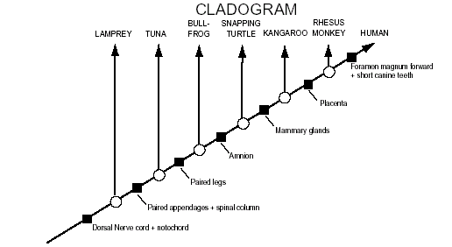

- Record the total number of amino acid differences between humans and each animal shown below. Write your answer in the hexagon below the arrow pointing to the name of that animal.
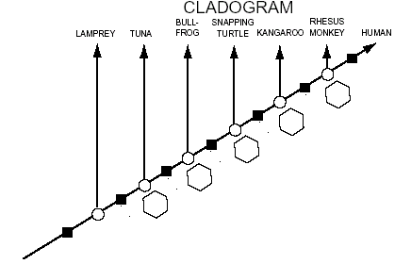

Post Lab Questions
  - Does the data from the amino acid sequence generally agree with the anatomical data that was used to make the cladogram?

  - Do organisms with fewer shared anatomical traits also have more amino acid differences?

  - Based on the molecular data, how does the "human-monkey" relationship compare to the "duck-chicken" relationship (which shows three amino acid differences)?

  - If the molecular data, the structural similarities, and the fossil record all support the same pattern of relationships, can we be fairly confident that the pattern is accurate? Why or why not?

  - Chickens and turkeys are both birds and have the same sequence of amino acids in their cytochrome-c protein. Explain how two species can have identical cytochrome-c and still be different species.

  - Neurospora (bread mold) and Saccharomycetes (bakers yeast) are both fungi. Chickens and turkeys are both birds. What can you say about the inferred evolutionary relationships between the two birds compared to the relationship between the two fungi? Explain your reasoning.

  - Write a short paragraph summarizing the important information that can be obtained from cladograms (not the information used to make them).

